

Practices for Secure Software Report

Table of Contents
Document Revision History 3
Client 3
Instructions 3
Developer 4
1. Algorithm Cipher 4
2. Certificate Generation 4
3. Deploy Cipher 4
4. Secure Communications 4
5. Secondary Testing 4
6. Functional Testing 4
7. Summary 4
8. Industry Standard Best Practices 4

Document Revision History

Version | Date | Author | Comments
1.0 | June 21, 2026 | Matthew Randall

Client
Artemis Financial is a consulting company that develops individualized financial plans for its customers, covering savings, retirement, investments, and insurance. The company operates a public web interface and has engaged Global Rain to modernize its operations and apply current, effective software security to protect its clients’ financial data. The objective of this engagement is to add a file-verification (checksum) capability and secure communications to the company’s existing web application.


Instructions

Submit this completed practices for secure software report. Replace the bracketed text with the relevant information. You must document your process for writing secure communications and refactoring code that complies with software security testing protocols.

- Respond to the steps outlined below and include your findings.
- Respond using your own words. You may also choose to include images or supporting materials. If you include them, make certain to insert them in all the relevant locations in the document.
- Refer to the Project Two Guidelines and Rubric for more detailed instructions about each section of the template.

Developer
Matthew Randall

Algorithm Cipher

For Artemis Financial’s encryption needs, the recommended cipher is the Advanced Encryption Standard with a 256-bit key operating in Galois/Counter Mode (AES-256-GCM). AES is a symmetric block cipher adopted by the U.S. National Institute of Standards and Technology (NIST) in 2001 and is the de facto worldwide standard for protecting data confidentiality. It operates on 128-bit blocks and supports key sizes of 128, 192, and 256 bits (NIST, 2023); the 256-bit key length is recommended here because it offers the strongest protection and is approved for the highest levels of classified information. GCM is an authenticated-encryption mode, which means it provides confidentiality and integrity at the same time: in addition to encrypting the data, it produces an authentication tag that detects any tampering. This pairs naturally with the scenario’s requirement to verify that transferred data has not been altered.
The integrity portion of this design relies on cryptographic hash functions, which is the mechanism actually deployed for the file-verification feature in this project. A cryptographic hash function takes an input of any length and produces a fixed-length, irreversible output called a digest, or checksum; any change to the input, even a single bit, produces a completely different digest. The application uses SHA-256, a member of the SHA-2 family, which produces a 256-bit (32-byte) digest displayed as a 64-character hexadecimal string (NIST, 2015). Bit length is what determines an algorithm’s strength: AES-256 uses a 256-bit key (2^256 possible keys), and SHA-256 produces a 256-bit digest with roughly 2^128 collision resistance under the birthday bound. These lengths place both algorithms well beyond the reach of brute-force attacks for the foreseeable future. By contrast, the older MD5 (128-bit) and SHA-1 (160-bit) hashes are now considered broken because practical collisions have been demonstrated, which is why SHA-256 is the appropriate minimum standard today.
Strong, unpredictable random numbers are essential to this cipher. AES-256-GCM requires a unique initialization vector, or nonce, for every encryption operation; reusing a nonce with the same key catastrophically breaks GCM’s security. These nonces, and the secret keys themselves, must be produced by a cryptographically secure pseudo-random number generator such as Java’s SecureRandom, never by a predictable source. The use of a single shared secret key for both encryption and decryption makes AES a symmetric cipher, which is fast and ideal for bulk data. This contrasts with asymmetric, or public-key, ciphers such as RSA, which use a mathematically linked public/private key pair to establish trust and exchange keys. Both types appear in this project: the self-signed certificate in Section 2 uses an RSA 2048-bit asymmetric key pair, and the HTTPS/TLS layer in Section 4 uses asymmetric cryptography during the handshake to authenticate the server before negotiating a fast symmetric session key for the actual data transfer.
Encryption has evolved from simple substitution ciphers, through the symmetric Data Encryption Standard (DES) of the 1970s, which is now obsolete because its 56-bit key is too short to resist modern brute-force attacks. DES was replaced by AES in 2001, and AES remains unbroken and is the current global standard for symmetric encryption. Current best practice combines AES-256 for confidentiality, RSA-2048 or elliptic-curve cryptography for key exchange and digital signatures, and SHA-256 or stronger for integrity, which is exactly the combination applied in this project. Looking ahead, the industry is actively preparing for post-quantum cryptography, because a sufficiently powerful quantum computer could break RSA and elliptic-curve cryptography; AES-256 and SHA-256 are considered comparatively quantum-resistant. For Artemis Financial’s present requirements, AES-256-GCM for confidentiality and integrity, supported by SHA-256 checksums, is the recommended, compliant, industry-standard choice.

Certificate Generation
Insert a screenshot below of the CER file.

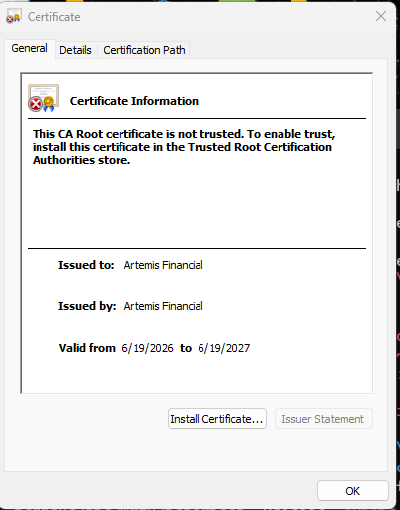

Deploy Cipher
Insert a screenshot below of the checksum verification.

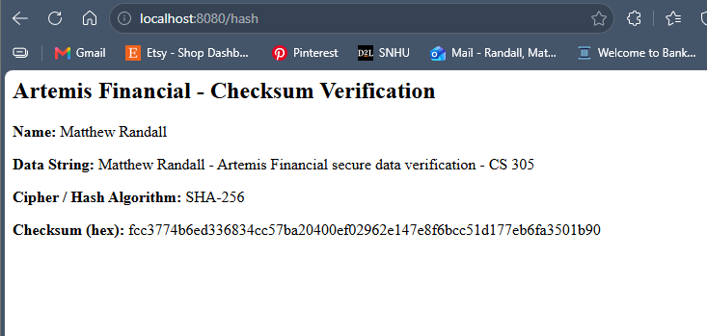

Secure Communications
Insert a screenshot below of the web browser that shows a secure webpage.

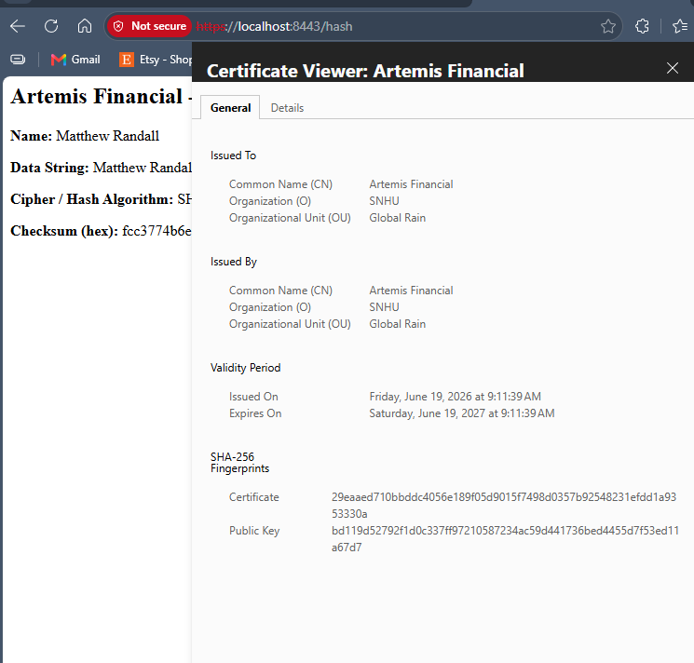

Secondary Testing
Insert screenshots below of the refactored code executed without errors and the dependency-check report.
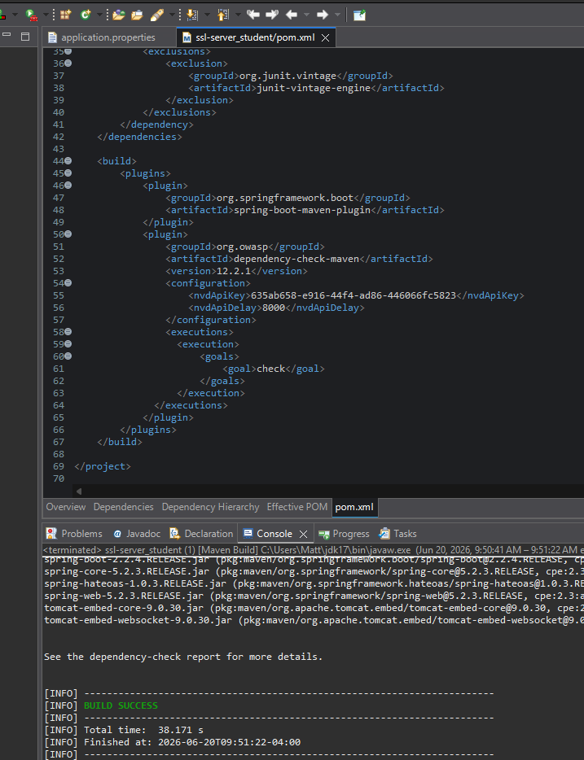
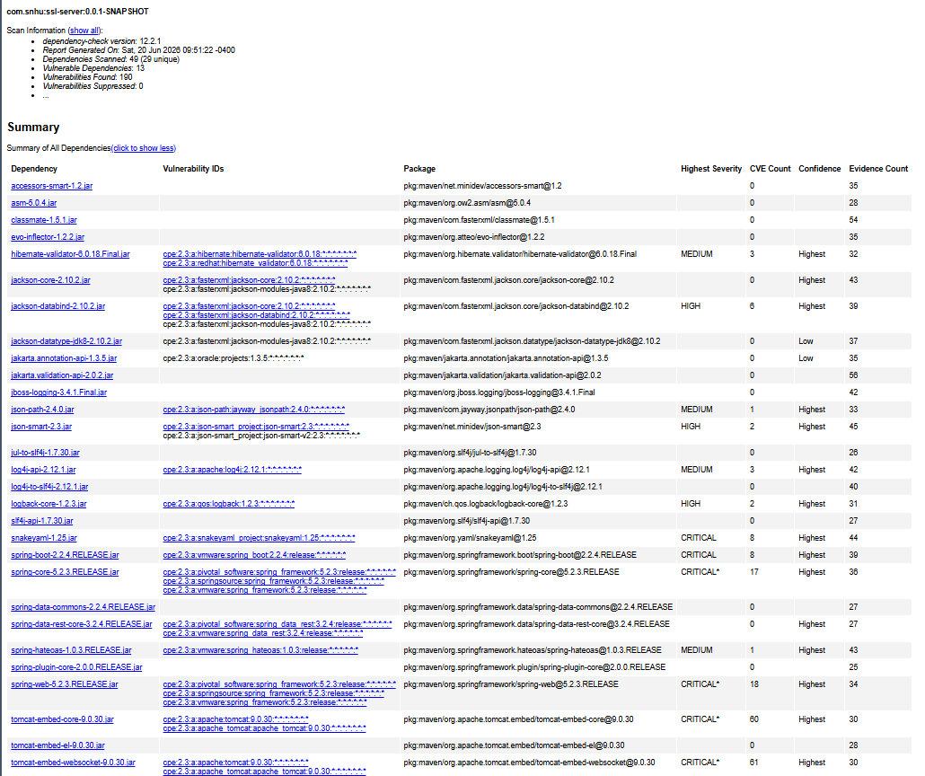

Functional Testing
Insert a screenshot below of the refactored code executed without errors.

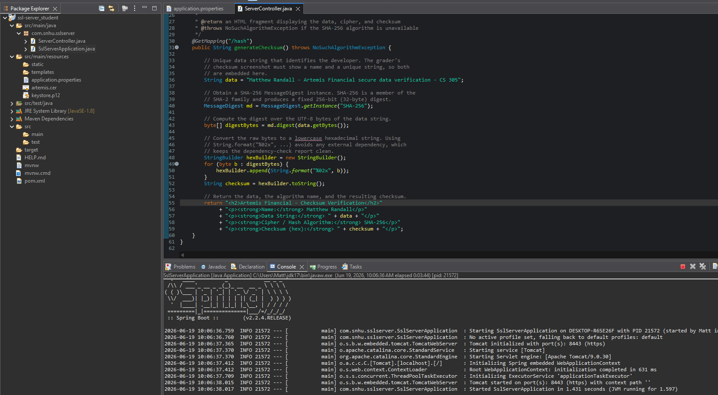

Summary

The refactoring addressed several of the security areas identified in the Vulnerability Assessment Process Flow diagram. Most directly, it strengthened the Cryptography node (Encryption Use and Vulnerabilities) by deploying a SHA-256 checksum for data integrity, and the Client/Server node (Secure Distributed Composing) by converting the application from HTTP to HTTPS so that all communication is encrypted in transit. The Code Quality node (Secure Coding Practices/Patterns) was addressed by implementing the checksum in a dedicated, well-documented controller and by avoiding deprecated APIs, and the Code Error node (Secure Error Handling) was addressed by declaring and propagating the NoSuchAlgorithmException rather than silently suppressing it. The Secondary Testing step exercised the APIs and Cryptography nodes again by running a completed OWASP dependency-check scan against the refactored code.
The process followed a defense-in-depth approach, adding security in layers rather than relying on any single control. First, integrity was added at the data layer through the SHA-256 checksum, allowing a recipient to detect tampering. Second, confidentiality and server authenticity were added at the transport layer by generating an RSA self-signed certificate and enabling TLS, so that data cannot be read or modified in transit and clients can verify they are communicating with the correct server. Third, the refactored code was validated through both automated static analysis using the OWASP dependency-check tool and manual functional review. The completed scan analyzed 49 dependencies (29 unique) and reported 13 vulnerable dependencies containing 190 known vulnerabilities; these findings reside entirely in pre-existing third-party framework libraries—chiefly Spring Boot 2.2.4 and the bundled Tomcat 9.0.30—rather than in the checksum and HTTPS code added during this engagement. Comparison against the initial vulnerability assessment confirms that the refactoring introduced no new vulnerabilities, and the recommended remediation for the inherited findings is to upgrade the Spring Boot parent version, which would cascade patched releases across the dependent libraries. Each layer compensates for the limitations of the others, which is the core principle of secure software design.

Industry Standard Best Practices

Several industry-standard secure-coding practices were applied so that the new functionality strengthened, rather than weakened, the application’s existing security posture. The implementation used vetted, standard cryptographic primitives from the Java Cryptography Architecture (MessageDigest) instead of writing custom cryptography, which is an OWASP-recommended practice (Oracle, 2021; OWASP Foundation, 2024). It relied on a current, unbroken algorithm, SHA-256, rather than the deprecated MD5 or SHA-1. Hexadecimal conversion was performed with standard library calls and no external dependency, so the dependency footprint remained small and auditable. The single endpoint operates only on static, server-controlled data, which keeps the attack surface minimal. Finally, the project enabled secure communications by default through HTTPS and verified the result with both automated static analysis using OWASP Dependency-Check (OWASP Foundation, n.d.) and manual code review, following the principle that security must be tested rather than assumed.
Applying these best practices has direct value to Artemis Financial’s overall well-being. Because the company handles sensitive financial information, including savings, retirement, investment, and insurance data, a breach would carry serious legal, regulatory, and reputational consequences. Verifiable data integrity and encrypted communications protect clients from tampering and eavesdropping, help the company meet its regulatory and contractual obligations, and preserve the customer trust on which a financial-planning business depends. Investing in secure coding early is also far less costly than remediating a breach after the fact. In keeping with Global Rain’s mission that security is everyone’s responsibility, these practices make security a built-in property of the software rather than an afterthought.
Acknowledgment of Generative AI Use
Generative AI was used to support the completion of this project. Specifically, Anthropic’s Claude was used to assist with troubleshooting the OWASP dependency-check plugin and NVD API configuration, interpreting the output of the dependency-check report, and providing drafting and editing assistance on portions of this report, including the Summary section. All code, security configurations, certificate and keystore generation, functional and secondary testing, screenshots, and final report content were produced, reviewed, and verified by the author. This use is acknowledged in accordance with the course generative AI usage guidelines, and the tool is cited below.
References
Anthropic. (2026). Claude (Opus 4.8) [Large language model]. https://claude.ai

National Institute of Standards and Technology. (2015). Secure hash standard (SHS) (FIPS PUB 180-4). U.S. Department of Commerce. https://doi.org/10.6028/NIST.FIPS.180-4

National Institute of Standards and Technology. (2023). Advanced encryption standard (AES) (FIPS PUB 197-upd1). U.S. Department of Commerce. https://doi.org/10.6028/NIST.FIPS.197-upd1

Oracle. (2021). MessageDigest [API documentation]. Java SE 17 & JDK 17. https://docs.oracle.com/en/java/javase/17/docs/api/java.base/java/security/MessageDigest.html

OWASP Foundation. (n.d.). OWASP Dependency-Check. https://owasp.org/www-project-dependency-check/

OWASP Foundation. (2024). OWASP secure coding practices quick reference guide. https://owasp.org/www-project-secure-coding-practices-quick-reference-guide/

